|  |
| --- |
| EPAM Systems, RD Dep. |
| MTN.BI.08 Advanced PL/SQL |

|  |  |  |  |  |  |
| --- | --- | --- | --- | --- | --- |
| REVISION HISTORY | | | | | |
| Ver. | Description of Change | Author | Date | Approved | |
| Name | Effective Date |
| 1.0 | Initial status | Hanna_Hul | 12-JAN-2012 |  |  |

Contents

1. Create Packages for Reload Dimension from DW to SAL 3

2. Task Results 3

# Create package to load the Fact Table into the staging (3NF) layer

The Main Task is to create independent package[s] to load your fact table to the ST layer, according to your DWH concept that was developed on Module 6 Introduction to DWH.

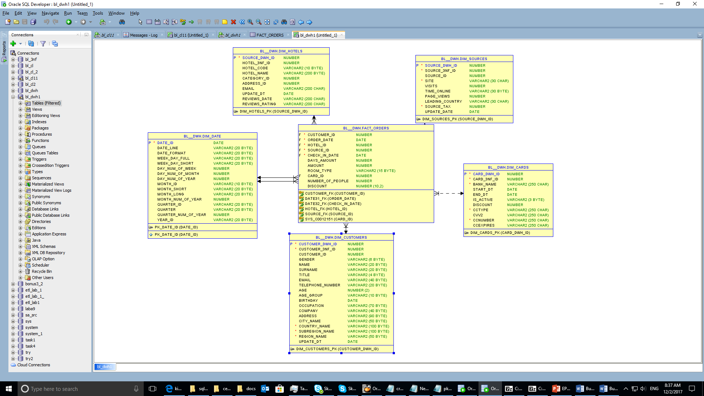

# Task Results

Create required objects:

* Create all required fact table objects on ST Layer (T_...).

CREATE TABLE fct_orders

(

customer_id NUMBER NOT NULL,

order_date DATE NOT NULL,

hotel_id NUMBER NOT NULL,

source_id NUMBER NOT NULL,

card_id number not null,

check_in_date DATE NOT NULL,

days_amount NUMBER,

amount NUMBER,

room_type VARCHAR2(15),

number_of_people NUMBER,

discount NUMBER(10,2),

CONSTRAINT customer_FK FOREIGN KEY ( customer_ID) REFERENCES dim_customers (customer_dwh_ID ),

CONSTRAINT hotel_FK FOREIGN KEY ( hotel_ID) REFERENCES dim_hotels( hotel_dwh_ID ),

CONSTRAINT source_FK FOREIGN KEY ( SOURCE_ID ) REFERENCES dim_sources (source_dwh_ID ),--,

CONSTRAINT date1_FK FOREIGN KEY ( order_date ) REFERENCES dim_date ( date_ID ),

CONSTRAINT date2_FK FOREIGN KEY ( check_in_date ) REFERENCES dim_date ( date_ID ),

CONSTRAINT cards_FK FOREIGN KEY ( CARD_ID ) REFERENCES dim_cards ( card_dwh_ID )

);

* Grant all required privileges to ST_CL (Cleansing Layer).

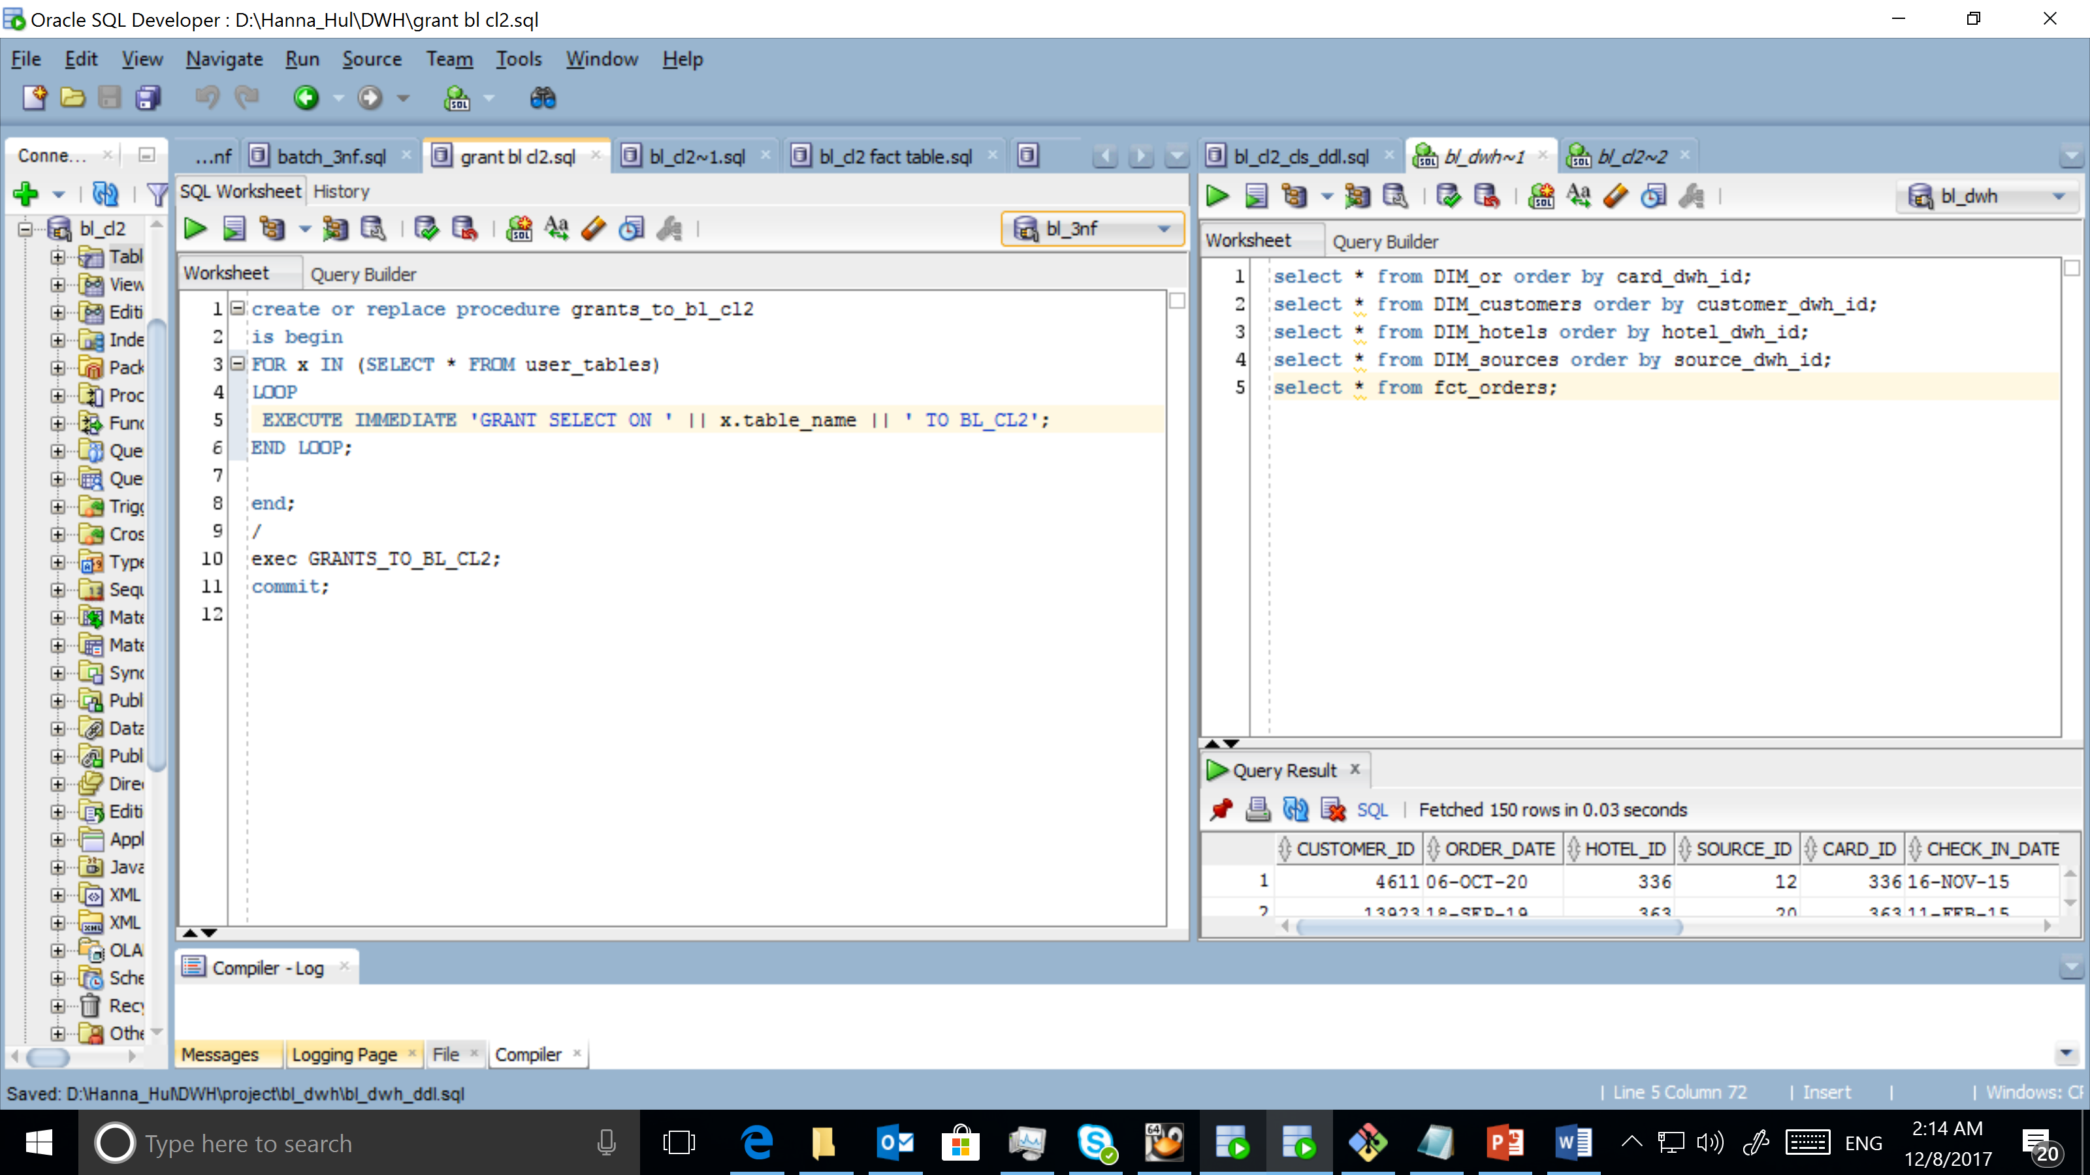

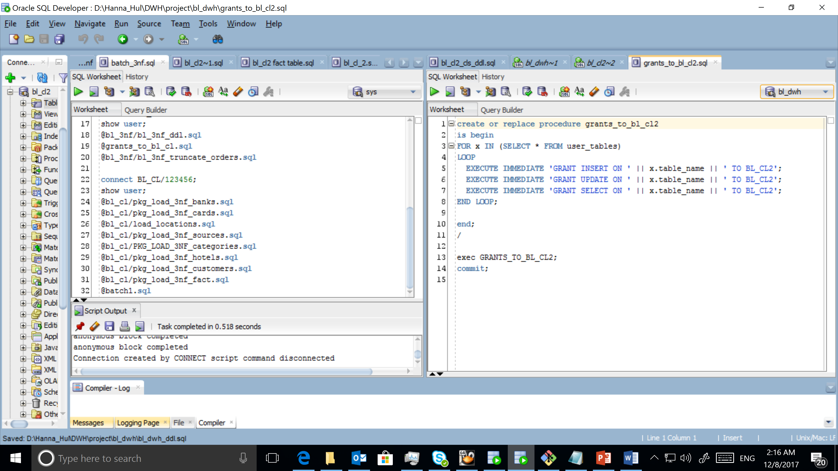

* Create packages to load fact data (one package = one fact table) on ST_CL.

CREATE OR REPLACE PACKAGE pkg_load_fact

AS

PROCEDURE cls_fact;

PROCEDURE dwh_fact;

END pkg_load_fact;

* Prepare document with description of your load and screenshot of data in the Fact Table.
* Test Procedure for Repeatable execution (it should produce same consistent results each time on a same source data).

